Session 8 - 1
class Solution {
public int maxSubArray(int[] nums) {
int maxSum = nums[0];
int currentSum = nums[0];
for (int i = 1; i < nums.length; i++) {
currentSum = Math.max(nums[i], currentSum + nums[i]);

maxSum = Math.max(maxSum, currentSum);
}

return maxSum;
}
}
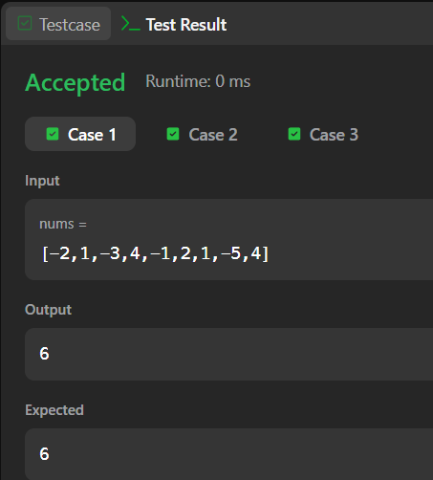

Session 8 - 2
class Solution {
public int largestAltitude(int[] gain) {
int maxAltitude = 0;
int currentAltitude = 0;

for (int i = 0; i < gain.length; i++) {
currentAltitude += gain[i];

if (currentAltitude > maxAltitude) {
maxAltitude = currentAltitude;
}
}
